RigBoard Phase 4 Requirement

# Original Requirement Meeting Notes by Chris

1. Tracking Bins
   * Add Bins Section on Resource board,
   * List should be filtered by selected District
   * Fields Required: Bin #, assignment(Rig# or yard), notes
   * Ability to transfer bin to another District
   * If bin not assigned to rig, then it’s in the yard
   * Ability to see history of bin assignment (possibly a BI report)
   * Ability to a tag notes on bins and see in bins section
   * Should use an operational location (working district) not AX District
     1. Bins might go out to another district for a job but won’t come back until there is a need for it to come back
     2. However ownership will not change.
   * Bin Type to track: Mega silos and P-tanks

1. Tracking other Equipment - Heads, Nubins, Misc
   * Add other equipment section to resource page similar to Bins
   * There is no serial number, identified by size. May be multiple per size
   * Types:
     1. Plug Loading Heads
     2. Nubins
     3. Swedges
     4. Squeeze manifolds
     5. WITS boxes
     6. Crossovers
   * No need to populate call sheet, as call sheet should already have it as indicator
   * Need ability to run a forecast report based on expected time on location to know if expect to be short equipment
   * Ability to Assign to crew
   * When crew returns – dispatch must manually specify return location
   * Require MDM for other equipment
   * Idea: Post job check list

以上表述中District同ServicePoint

# Requirement Explanation by Adam

1. Bin Tracking

Bin Assignment已经在当前RigBoard中实现了，这里需要重新描述业务场景以助于下一步的重构和开发。

Bin 是Sanjel分配给井架的用来贮存干水泥的容器，目前只有P-Tank和Mego Silo两种类型。它在分配给井架之后，就会一直跟着井架走，直到有人把它解除分配。解除分配后就认为是In Yard状态。否则是Assigned状态，并且知道是分配给哪个Rig了。

每个Bin有它的所属的ServicePoint，它可以在各地区间进行转借，基本业务逻辑与Crew相似。需要加上相关属性。

在Resource Board上新增Bin Board，现在要求有三列:

* Bin Number
* Location - 显示Rig Name或是Yard
* Notes – 可以添加Notes

在把eService中的Bin和Bin Type迁移到MDD后，可以根据以上需求进行扩展。

1. 追踪其他设备

设备类型包括：

* + 1. Plug Loading Heads
    2. Nubins
    3. Swedges
    4. manifolds
    5. Electronic Equipment (目前只有WITS boxes)
    6. Crossovers (即X Over)

这些设备目前没有Master Data，需要新建。各个类型设备的属性各不相同，但是跟踪方法相同，注意统一方法。它们的业务逻辑和属性，参考eService 中的如下页面和Compliant Head Tracking Sheet.xslx文件。目前相关属性理解不了，不准确也不要紧，等我休假回来再完善。抓主要矛盾，实体关系不错就行。

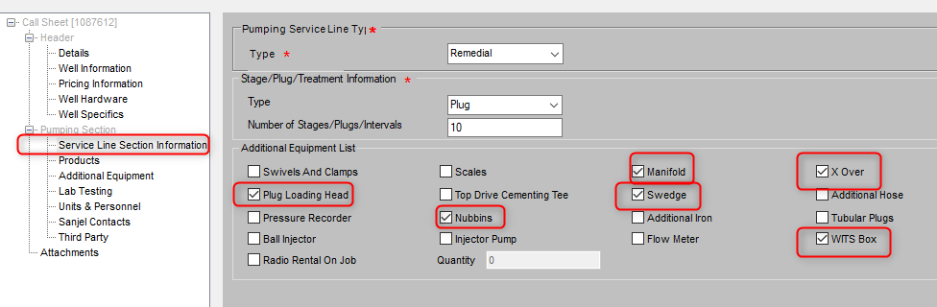

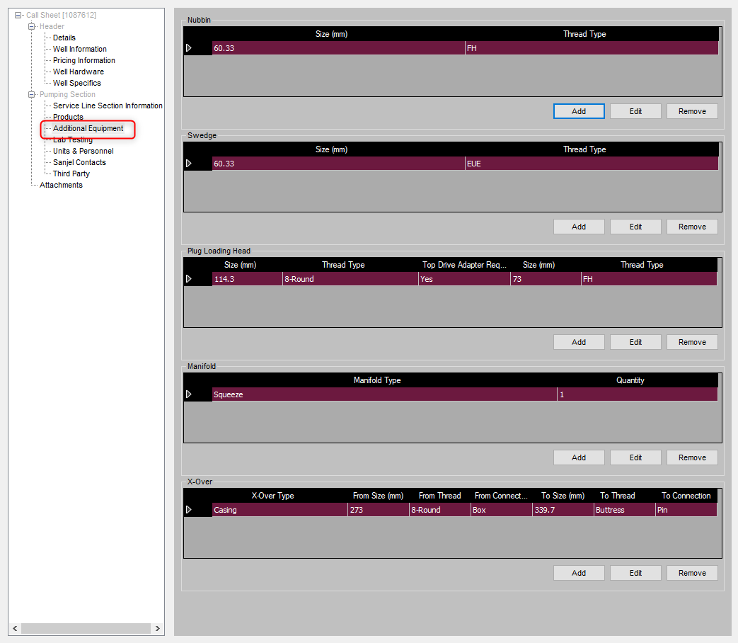

此部分没有和eService call sheet 集成的需要，Dispatcher 仍然按原来的逻辑在call sheet 中手工选择和输入，他们的输入，在后面会成为后面业务流程的需求。

用户说不需要设备序列号，因为在使用的时候，只要尺寸对了，Field Supervisor就拿一个好的走，并不会留意序列号。但是我们系统设计时，需要唯一标识，所以序列号属性要有，目前用顺序编号就可以，反正也不显示出来。

在Resouce Board上为每个设备建一个Board，包括如下列。

Size

Thread Type

XOver Type – 只适用 X Over

Type - 只适用Manifold (目前只有Squeeze) 和 Electronic Equipment (目前只有WITS Box)

Location – Assigned (显示分配给的Crew), Yard (Returned from a crew)

Home Service Point和Working Service Point 的业务数据和逻辑适用所有的设备类型。

Dispatcher可以点击一个Job，Assign [Equipment]

Dispatcher 可以点击一个Assigned 设备, Return [Equipment] 设备可以Return 到其他Service Point